What Is InnerHTML?
InnerHTML is used for getting or setting a content of the selected while outerHTML is used for getting or setting content with the selected tag.
From the above difference between innerHTML & outerHTML one can elaborate that innerHTML represents the inner elements of HTML, this is based entirely upon how they treat the attributes of features, and outerHTML represents the similarity with innerHTML, it includes the contents, but it does also include the opening & closing tags.

We must be having fundamentals of the HTML, so the phrase "HTML for Beginners, Learn HTML & CSS" will help them get out their trouble.

Syntax
- const content = element.innerHTML;
- const content = element.innerHTML;

innerHTML Example

< script >
function Msg1(){
document.getElementById('myText').innerHTML = 'Hello World';
}
function Msg2(){
document.getElementById('myText').innerHTML = 'Nice to meet...';
}

< input type="button" onclick="Msg1()" value="Show Message 1">
< input type="button" onclick="Msg2()" value="Show Message 2">
< p id="myText">

Here in this program clicking on the options called Msg1 & Msg2, we will get the messages which we have stored previously in these two functions.

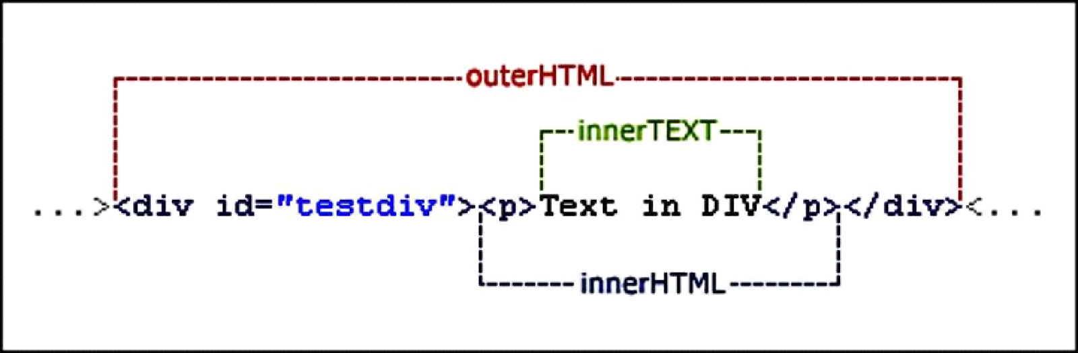
What Is OuterHTML?
The outerHTML is the HTML of an element including the element itself. Contrast this with the innerHTML of the element, which is the HTML contained within an elements opening and closing tags.

Syntax
- var content = element.outerHTML;
- element.outerHTML = content;

outerHTML Example

< div id= "hello" >
< div id= "world" >Javascript

< script >
Document.getElementById('world').outerHTML = '< p >Example outerHTML � exists';
/*Result:
< div id = "Hello" >
< p >Example outerHTML - exists

*/

From all these above discussions on the innerHTML & outerHTML and of the difference between innerHTML & outerHTML, we can conclude that for web development services of any type of webpage and introducing relevant contents to it one needs a basic concept on it.

